Design and Deployment Guide

HAUL-NRT

|  |
| --- |
|  |
| Document Reference |
|  |
|  |

1. Documentation change log

*Document signoffs should be included here as per document change control standards.*

***Disclaimer:***

***This document is protected by copyright, no part of this document may be reproduced or adapted without the consent of the originator/company owner, all rights are reserved. This document is “uncontrolled when printed”, refer to electronic copy for up to date version***.

|  |  |  |  |
| --- | --- | --- | --- |
|  | Product Handover: Fortescue Insights | | Doc Ref |
| **Revision Number** | **1.1** | |  |
| **Status** | Choose an item. | |
| **Authors** | Jay Tripathy | Signature | **27/01/2020** |
| **Checked** |  | Signature | Click here to enter a date. |
| **Accepted**  **IT Applications Development** |  | Signature | Click here to enter a date. |
| **Confidentiality** | **Fortescue Staff & Contractors** | **Publish on Extranet** | ☐ Yes |
| ☐ No |
| **Review Date** | Click here to enter a date. | | |

|  |  |  |  |  |  |
| --- | --- | --- | --- | --- | --- |
| Revision History *(to be completed for each version retained by Document Control)* | | | | | |
| **Author** | **Checker** | **Approver** | **Rev No.** | **Status** | **Issued Date** |
| **Jay Tripathy** | **Sourabh Tewari** | **Nageshwar Pinna** |  | Choose an item. | Click here to enter a date. |

|  |  |  |  |  |
| --- | --- | --- | --- | --- |
| Handover Details | |  | | |
| **Attendee** | **Signature** | | **Date** |
|  |  | |  |

**TABLE OF CONTENTS**

1. Documentation change log 2

2. Document purpose 6

3. Project purpose 6

3.1 Requirement 7

4. Project Team Contact Details 7

5. Solution Design 7

5.1 Solution Overview 7

5.1.1 HAUL NRT Architecture 7

5.1.2 HAUL NRT Environment Design Diagram 8

5.1.3 Database Diagram 9

6. Application Screen design and details 10

6.1 Haul - NRT Screens 10

6.1.1 Dashboard Page 10

6.1.2 Sidebar 12

6.1.3 Crusher 13

6.1.4 Summary Tiles View 13

6.1.5 Avg. Queue At Source 13

6.1.6 Avg. Queue At Sink 14

6.1.7 Estimated Time/Truck 14

6.1.8 Avg. True Hang Time 14

6.1.9 Avg. Speed 15

6.1.10 Total Tonnes 15

6.1.11 Summary Icons 16

6.1.12 Engine Derate 16

6.1.13 Hot Tyres 17

6.1.14 Released From Maintenance 17

6.1.15 No Operators 17

6.1.16 In Maintenance 18

6.3.17 Planned Vs Actual Destination (020 Report) 18

6.3.18 Connected for Notification 19

6.3.19 Asset Details 19

6.3.20 Tyre Sense UI 20

6.3.21 Tyre Sense UI for Individual Tyre 20

6.3.22 Truck Model Details 21

6.3.23 Process Health 22

6.3.24 Tyre Health 22

7. Deployment steps 23

7.1 Fresh Deployment of the Application 23

7.1.1 Pre requisites 23

7.1.2 Installation steps 23

7.2 Uninstallation of the Application 23

7.2.1 Pre requisites 23

7.2.2 Uninstall steps 23

7.2.3 Post Uninstall steps 23

8. Environment & CONFIGURATION detail 24

8.1.1 SSO Config 24

8.1.2 Publishing Application 24

8.1.3 Subscribing Application 24

1. Document purpose

This document provides the functional and technical overview of Haul-NRT Application for Solomon, Christmas Creek and Cloudbreak sites. Objective for preparing this document is to capture comprehensive knowledge about Haul-NRT in a single place. Thus, reducing effort of readers to refer multiple documents.

1. Project purpose

Haul NRT is a near real time reporting platform (via. A dashboard) for asset information to help Mine controllers make valuable decisions in operating the automotive Trucks.

Haul NRT is a set of tools as a portal which handles the movable assets data and screens from minestar.

A number of areas within Mine control have been identified where data can be used more-timely to improve efficiency.

**Business Objective:**

* Increased reliability, security and supportability of data sharing, event detection and alerting for use by all sites
* Support Operational System Integration to enable automation between Mine and Processing.
* Foundational IT/OT platform connectivity, notification and persistence solution for current and future requirements.
* Develop a Haul Near-Real-Time (NRT) reporting platform to perform the following:
* Protect the trucks and network operating environment (system architecture).
* Provide decision support tools for operations teams (User Interface).
* Establish the platform for data availability and data flows for future capability in advanced analytics (analytics and integration).
* Provide decision making tools prior to an event occurring which would result in a productivity impact (Level 0 alerts).
  1. Requirement
* Increased reliability, security and supportability of data sharing, event detection and alerting for use by all sites
* Support Operational System Integration to enable automation between Mine and Processing.
* Foundational IT/OT platform connectivity, notification and persistence solution for current and future requirements.
* Develop a Haul Near-Real-Time (NRT) reporting platform to perform the following:
* Protect the trucks and network operating environment (system architecture).
* Provide decision support tools for operations teams (User Interface).
* Establish the platform for data availability and data flows for future capability in advanced analytics (analytics and integration).
* Provide decision making tools prior to an event occurring which would result in a productivity impact (Level 0 alerts).

1. Project Team Contact Details

|  |  |  |
| --- | --- | --- |
| Role | Name | Contact Details |
| Product Owner |  |  |
| Key Users |  |  |
| Product Designer | Sourabh Tewari  Nageshwar Pinna | [stewari@fmgl.com.au](mailto:stewari@fmgl.com.au)  npinna@fmgl.com.au |
| Product Developers | Naren Venkobarao  Jay Tripathy | nvenkobarao@fmgl.com.au  [jtripathy@fmgl.com.au](mailto:jtripathy@fmgl.com.au) |

1. Solution Design
   1. Solution Overview
      1. HAUL NRT Architecture Diagram

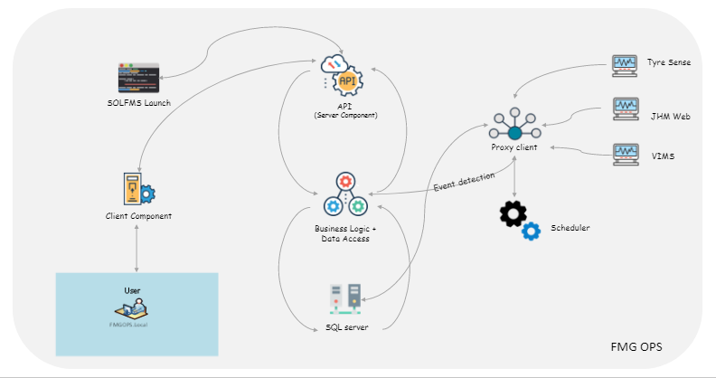

* + 1. HAUL NRT Environnent Design Diagram

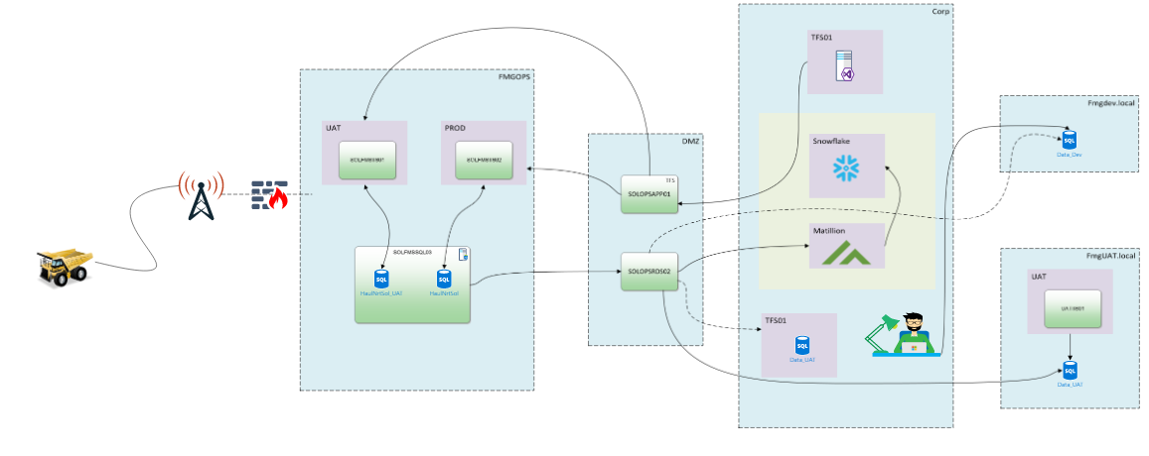

* + 1. Database Diagram



1. Application Screen design and details
   1. Haul NRT Solomon Screens

## Dashboard Page:

### Dashboard will show overview of assets related information.

## 

|  |  |
| --- | --- |
| **Actions/Buttons** | **Descriptions** |
| Sidebar | Provide menu list with currently login user information. |
| Crusher | Display information related with crusher. |
| Summary tiles view | It loads the summary data of tiles view. |
| Summary icons | Display current status of all asset summary with notification. |
| Planned Vs Actual destination report | It redirect to planned vs actual destination report. |
| Connected for notification | Plug in icon shows the connected for notification status. |
| Truck(Asset) | All truck(asset) information with status. |
| Process health | Display information about process health of Haul NRT. |
| Tyre health | Display information about tyre health of asset. |

## Sidebar :

### It shows the menu of Haul-NRT.

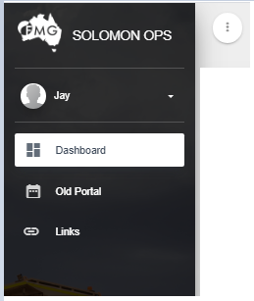

|  |  |
| --- | --- |
| **Actions/Buttons** | **Descriptions** |
| Sidebar icon | It is used to expand/collapse sidebar screen. |
| User Setting | User can manage account related setting. |
| Dashboard | Display dashboard page. |
| Old portal | Display old portal of Haul-NRT application. |
| Links | It redirect to specified URL. |

## 

## Crusher :

### It shows the information about crusher.

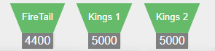

## Summary Tiles View :

### It shows the information about summary tiles view details. Also the summary avg value is highlighted with color based on threshold value.

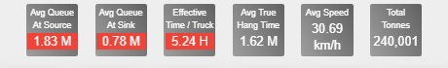

## Avg Queue at Source :

### It shows the information about avg queue at source current/previous details.

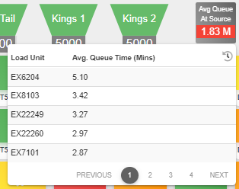 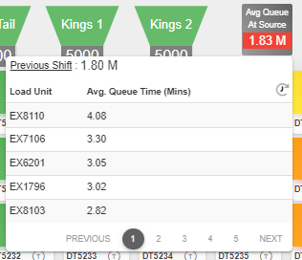

## Avg Queue at Sink :

### It shows the information about avg queue at sink current/previous details.

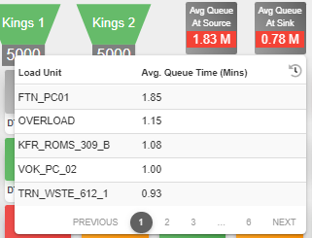 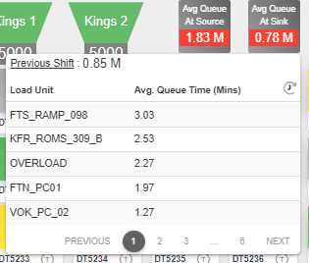

## Estimated Time/ Truck :

### It shows the information about avg estimated time/truck details.

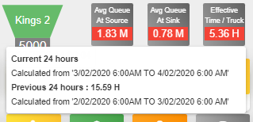

## Avg True Hang Time :

### It shows the information about avg true hang time current/previous details.

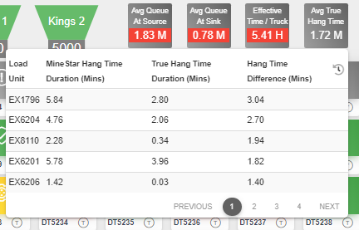 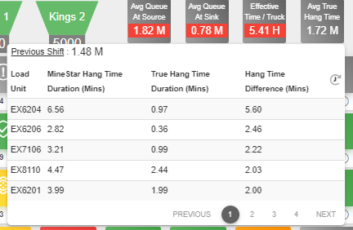

## Avg Speed :

### It shows the information about avg speed details.

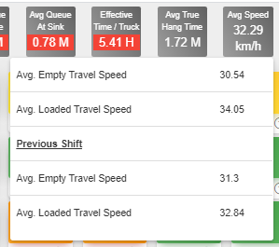

## Total Tonnes :

### It shows the information about total tonnes details.

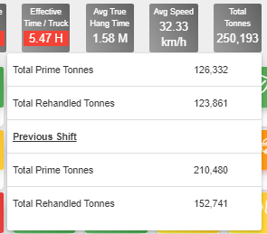

## Summary Icons :

### Display current status of all asset summary with notification.



|  |  |
| --- | --- |
| **Actions/Buttons** | **Descriptions** |
| Engine Derate | Display the information about truck engine related information. |
| Hot Tyres | Display the information about truck tyres related information. |
| Released From Maintenance | Provide information about truck released from maintenance. |
| No Operator | Provide information about no operator is available for truck. |
| In Maintenance | Provide information about truck in maintenance. |
| Planned Vs Actual Destination (020 Report) | It redirect to planned vs actual destination report. |
| Connected for Notification | Plug in icon shows the connected for notification status. |

## Engine Derate :

### Display current status of engine derate asset summary.

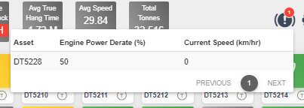

|  |  |
| --- | --- |
| **Actions/Buttons** | **Descriptions** |
| Asset | User can open tyre sense UI after click on asset name hyperlink. |

## Hot Tyres :

### Display current status of hot tyres asset summary.

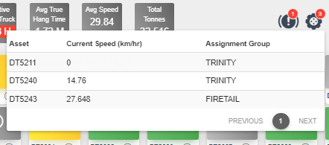

|  |  |
| --- | --- |
| **Actions/Buttons** | **Descriptions** |
| Asset | User can open tyre sense UI after click on asset name hyperlink. |

## Released From Maintenance :

### Display list of asset summary which are in released from maintenance event.

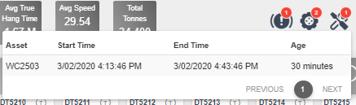

## No Operators :

### Display list of asset summary which are in no operator event.

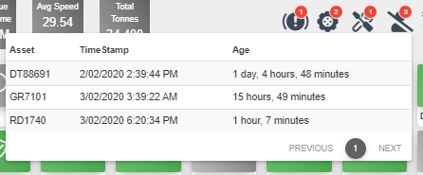

## In Maintenance :

### Display list of asset summary which are in maintenance process.

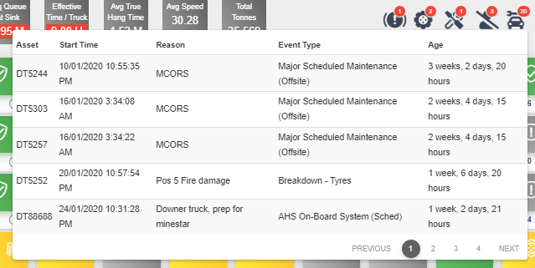

## Planned Vs Actual Destination (020 Report) :

### Display report of planned vs actual destination.

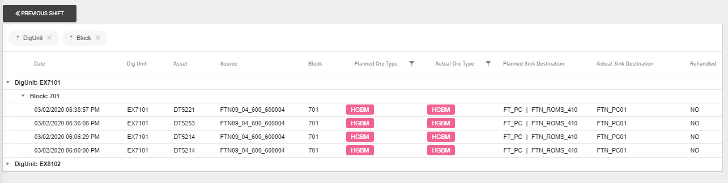

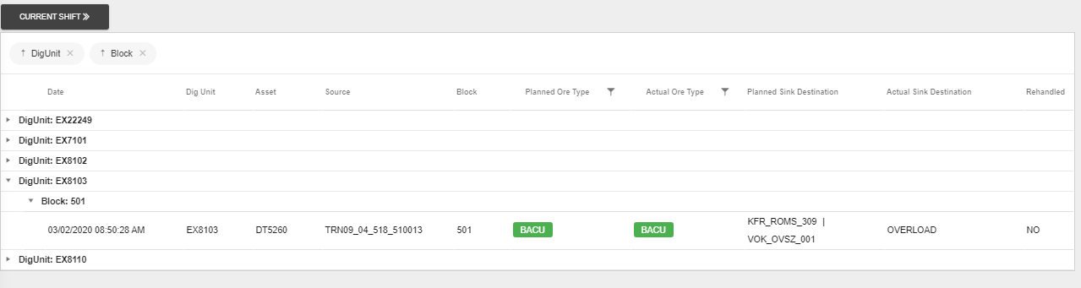

|  |  |
| --- | --- |
| **Actions/Buttons** | **Descriptions** |
| Toggle button | Current/Previous shift toggle button click load the report based on user requested . |

## Connected for Notification :

### Plug in icon shows connected/disconnected status for notification through SignalR.

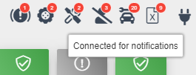

## Asset Details :

### Display all asset information with event type and severity.

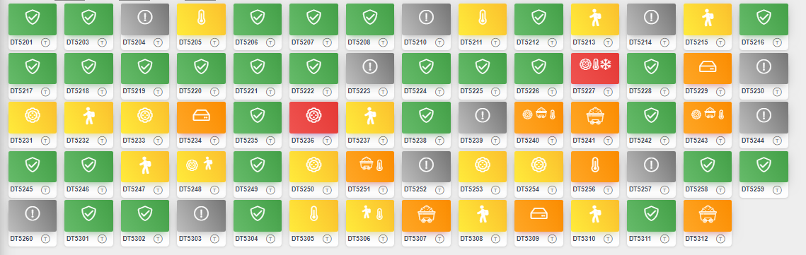

|  |  |
| --- | --- |
| **Actions/Buttons** | **Descriptions** |
| Online | It shows asset online status. |
| Carryback | It shows asset carryback status. |
| TKPH | It shows asset TKPH status. |
| Overload | It shows asset overload status. |
| Data Logger | It shows asset data logger status. |
| Temperature | It shows asset temperature status. |
| Cold Pressure | It shows asset cold pressure status. |
| Common Issue | It shows asset offline status. |
| Severity | Health severity of asset can be Normal, Caution, Critical and Extreme. |

## Tyre Sense UI :

### It shows the information about truck of all wheels with age timestamp.

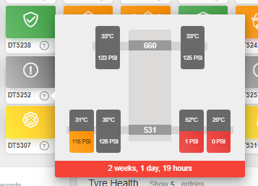

## Tyre Sense UI for Individual Tyre:

### It shows the information about individual tyre of truck with age timestamp.

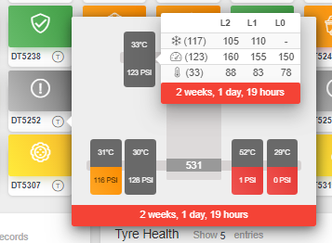

## Truck Model Details:

### It shows the information about truck events with statistics.

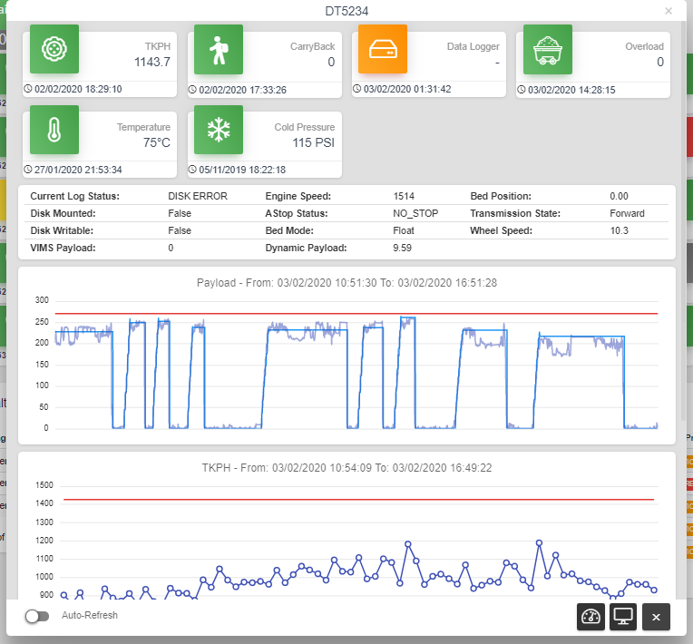

|  |  |
| --- | --- |
| **Actions/Buttons** | **Descriptions** |
| Auto-Refresh | Its refresh the truck model details after every 15 seconds interval. |
| JHM Dash/Web | Its redirect to JHM URL. |
| Close | Its close the model popup. |

## Process Health:

### It shows the information about process health with age of events and statistics.

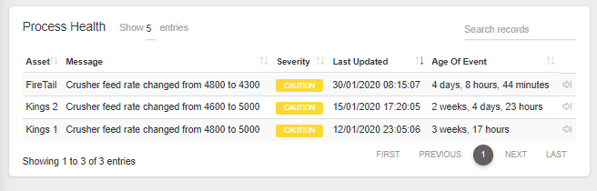

|  |  |
| --- | --- |
| **Actions/Buttons** | **Descriptions** |
| Close | Its close the process health notification and update into database. |
| search | User search records from the list. |

## Tyre Health:

### It shows the information about tyre health with severity.

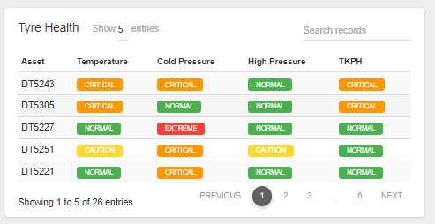

|  |  |
| --- | --- |
| **Actions/Buttons** | **Descriptions** |
| Asset | User can open tyre sense UI after click on asset name hyperlink. |
| Search | User search records from the list. |

1. Deployment steps
   1. Fresh Deployment of the Application
      1. Pre requisites

NA

* + 1. Installation steps

NA

* 1. Uninstallation of the Application
     1. Pre requisites
* Back Up of all the existing Application.
  + 1. Uninstall steps
* Execute the Roll Back scripts.
* Undeployed and uninstall the applications.
  + 1. Post Uninstall steps

NA

1. Environment & CONFIGURATION detail
   * 1. SSO Config

|  |  |
| --- | --- |
| **NA** | NA |
| **NA** | NA |

* + 1. Publishing Application

NA

* + 1. Subscribing Application

NA